
Ore Research & Exploration P/L ABN 28 006 859 856
37A Hosie Street, Bayswater North, VIC 3153, Australia
P +61 3 9729 0333 | E info@ore.com.au | oreas.com

CERTIFICATE OF ANALYSIS FOR

CERTIFIED REFERENCE MATERIAL
OREAS 262b
Gold-bearing oxide (Australia and Laos)

Table 1. Certified Value, Uncertainty & Tolerance Intervals for Au by FA in OREAS 262b.
Constituent | Certified  Value† | 95% Expanded Uncertainty |  | 95% Tolerance Limits
Constituent | Certified  Value† | Low | High | Low | High
Pb Fire Assay
Au, Gold (ppb) | 104 | 101 | 107 | 102* | 106*
SI unit equivalents: ppb (parts per billion; 1 x 10⁻⁹) ≡ µg/kg. Note: intervals may appear asymmetric due to rounding.
†This operationally defined measurand meets the requirements of ISO 17034 and all participating laboratories comply with the requirements of ISO 17025.
*Gold Tolerance Limits for typical 30g fire assay are determined from 20 x 85mg INAA results and the Sampling Constant (Ingamells & Switzer, 1973).

Table 2. Certified Value, Uncertainty & Tolerance Intervals for other measurands in OREAS 262b.
Constituent | Certified  Value | 95% Expanded Uncertainty |  |  |  | 95% Tolerance Limits
Constituent | Certified  Value | Low |  | High |  | Low |  | High
Aqua Regia Digestion (sample mass 10-50g)
Au, Gold (ppb) | 93.5 | 86.8 |  | 100.3 |  | 91.3* |  | 95.7*
Cyanide Leach
Au, Gold (ppb) | 82.1 | 74.6 |  | 89.6 |  | 81.4* |  | 82.8*
PhotonAssay (recommended gross mass 470-500 g)
Au, Gold (ppb) | 108 |  | 102 |  | 114 |  | 107* |  | 109*
4-Acid Digestion
Ag, Silver (ppm) | 0.158 |  | 0.125 |  | 0.190 |  | IND |  | IND
Al, Aluminium (wt.%) | 5.01 |  | 4.85 |  | 5.17 |  | 4.91 |  | 5.11
As, Arsenic (ppm) | 30.3 |  | 28.0 |  | 32.5 |  | 28.6 |  | 31.9
Ba, Barium (ppm) | 336 |  | 325 |  | 347 |  | 330 |  | 343
Be, Beryllium (ppm) | 1.52 |  | 1.46 |  | 1.57 |  | 1.47 |  | 1.56
Bi, Bismuth (ppm) | 0.73 |  | 0.68 |  | 0.79 |  | 0.71 |  | 0.76
Ca, Calcium (wt.%) | 0.384 |  | 0.369 |  | 0.398 |  | 0.374 |  | 0.393
Cd, Cadmium (ppm) | 0.062 |  | 0.043 |  | 0.080 |  | 0.055 |  | 0.068
Ce, Cerium (ppm) | 68 |  | 65 |  | 71 |  | 66 |  | 70
Co, Cobalt (ppm) | 5.74 |  | 5.41 |  | 6.06 |  | 5.56 |  | 5.91
Cr, Chromium (ppm) | 49.7 |  | 46.3 |  | 53.0 |  | 47.6 |  | 51.7
Cs, Caesium (ppm) | 5.02 |  | 4.79 |  | 5.25 |  | 4.88 |  | 5.16
Cu, Copper (ppm) | 70 |  | 67 |  | 73 |  | 68 |  | 73
Dy, Dysprosium (ppm) | 2.37 |  | 1.94 |  | 2.80 |  | 2.21 |  | 2.53
Er, Erbium (ppm) | 1.31 |  | 1.14 |  | 1.47 |  | 1.21 |  | 1.40
Eu, Europium (ppm) | 0.74 |  | 0.68 |  | 0.79 |  | 0.69 |  | 0.78
Fe, Iron (wt.%) | 2.46 |  | 2.39 |  | 2.53 |  | 2.41 |  | 2.51
Ga, Gallium (ppm) | 12.6 |  | 11.9 |  | 13.3 |  | 12.2 |  | 13.0
Gd, Gadolinium (ppm) | 3.35 |  | 2.92 |  | 3.79 |  | 3.14 |  | 3.56
Hf, Hafnium (ppm) | 2.54 |  | 2.32 |  | 2.75 |  | 2.39 |  | 2.68
Ho, Holmium (ppm) | 0.43 |  | 0.37 |  | 0.49 |  | 0.39 |  | 0.47
In, Indium (ppm) | 0.063 |  | 0.056 |  | 0.071 |  | 0.057 |  | 0.069
K, Potassium (wt.%) | 1.63 |  | 1.57 |  | 1.70 |  | 1.59 |  | 1.67
La, Lanthanum (ppm) | 34.6 |  | 32.8 |  | 36.3 |  | 33.4 |  | 35.8
Li, Lithium (ppm) | 34.9 |  | 33.6 |  | 36.1 |  | 33.9 |  | 35.9
Lu, Lutetium (ppm) | 0.19 |  | 0.15 |  | 0.23 |  | 0.18 |  | 0.21
Mg, Magnesium (wt.%) | 0.557 |  | 0.537 |  | 0.576 |  | 0.544 |  | 0.569
Mn, Manganese (wt.%) | 0.019 |  | 0.018 |  | 0.019 |  | 0.018 |  | 0.019
Mo, Molybdenum (ppm) | 1.48 |  | 1.28 |  | 1.68 |  | 1.34 |  | 1.63
Na, Sodium (wt.%) | 0.190 |  | 0.181 |  | 0.198 |  | 0.184 |  | 0.196
SI unit equivalents: ppb (parts per billion; 1 x 10⁻⁹) ≡ µg/kg; ppm (parts per million; 1 x 10⁻⁶) ≡ mg/kg; wt.% (weight per cent) ≡ % (mass fraction).
*Gold Tolerance Limits for typical 25g aqua regia digestion and 200g cyanide leach methods and 470-500g PhotonAssay methods are determined from 20 x 85mg INAA results and the Sampling Constant (Ingamells & Switzer, 1973).
Note: intervals may appear asymmetric due to rounding; IND = indeterminate (due to limited reading resolution of the methods employed).
Table 2 continued.
Constituent | Certified | 95% Expanded Uncertainty |  |  |  | 95% Tolerance Limits
Constituent | Value | Low |  | High |  | Low |  | High
4-Acid Digestion continued
Nb, Niobium (ppm) | 7.70 |  | 6.86 |  | 8.54 |  | 7.21 |  | 8.20
Nd, Neodymium (ppm) | 24.0 |  | 18.9 |  | 29.0 |  | 23.3 |  | 24.7
Ni, Nickel (ppm) | 22.0 |  | 20.4 |  | 23.7 |  | 21.1 |  | 22.9
P, Phosphorus (wt.%) | 0.024 |  | 0.022 |  | 0.025 |  | 0.023 |  | 0.024
Pb, Lead (ppm) | 19.4 |  | 18.5 |  | 20.2 |  | 18.7 |  | 20.0
Pr, Praseodymium (ppm) | 6.97 |  | 6.13 |  | 7.81 |  | 6.65 |  | 7.28
Rb, Rubidium (ppm) | 110 |  | 105 |  | 116 |  | 107 |  | 114
Re, Rhenium (ppm) | < 0.002 |  | IND |  | IND |  | IND |  | IND
S, Sulphur (wt.%) | 0.036 |  | 0.033 |  | 0.040 |  | 0.035 |  | 0.038
Sb, Antimony (ppm) | 5.41 |  | 5.09 |  | 5.73 |  | 5.13 |  | 5.68
Sc, Scandium (ppm) | 7.02 |  | 6.59 |  | 7.44 |  | 6.78 |  | 7.26
Sm, Samarium (ppm) | 4.35 |  | 3.88 |  | 4.82 |  | 4.13 |  | 4.58
Sn, Tin (ppm) | 6.72 |  | 6.40 |  | 7.05 |  | 6.41 |  | 7.04
Sr, Strontium (ppm) | 44.1 |  | 41.9 |  | 46.3 |  | 43.2 |  | 45.0
Ta, Tantalum (ppm) | 0.78 |  | 0.68 |  | 0.88 |  | 0.73 |  | 0.83
Tb, Terbium (ppm) | 0.45 |  | 0.39 |  | 0.51 |  | 0.42 |  | 0.48
Te, Tellurium (ppm) | 0.11 |  | 0.08 |  | 0.14 |  | IND |  | IND
Th, Thorium (ppm) | 12.6 |  | 11.9 |  | 13.3 |  | 12.3 |  | 12.9
Ti, Titanium (wt.%) | 0.253 |  | 0.238 |  | 0.267 |  | 0.243 |  | 0.262
Tl, Thallium (ppm) | 0.88 |  | 0.83 |  | 0.93 |  | 0.84 |  | 0.92
Tm, Thulium (ppm) | 0.18 |  | 0.16 |  | 0.20 |  | IND |  | IND
U, Uranium (ppm) | 1.95 |  | 1.83 |  | 2.07 |  | 1.88 |  | 2.01
V, Vanadium (ppm) | 51 |  | 49 |  | 54 |  | 50 |  | 53
W, Tungsten (ppm) | 3.07 |  | 2.80 |  | 3.34 |  | 2.84 |  | 3.30
Y, Yttrium (ppm) | 12.0 |  | 11.1 |  | 12.9 |  | 11.6 |  | 12.5
Yb, Ytterbium (ppm) | 1.30 |  | 1.11 |  | 1.48 |  | 1.25 |  | 1.35
Zn, Zinc (ppm) | 47.2 |  | 45.1 |  | 49.2 |  | 46.1 |  | 48.3
Zr, Zirconium (ppm) | 89 |  | 83 |  | 95 |  | 87 |  | 92
Aqua Regia Digestion
Ag, Silver (ppm) | 0.132 |  | 0.118 |  | 0.147 |  | IND |  | IND
Al, Aluminium (wt.%) | 0.922 |  | 0.821 |  | 1.024 |  | 0.888 |  | 0.957
As, Arsenic (ppm) | 13.9 |  | 13.0 |  | 14.8 |  | 13.4 |  | 14.3
B, Boron (ppm) | < 10 |  | IND |  | IND |  | IND |  | IND
Ba, Barium (ppm) | 75 |  | 69 |  | 80 |  | 72 |  | 77
Be, Beryllium (ppm) | 0.47 |  | 0.43 |  | 0.51 |  | 0.46 |  | 0.48
Bi, Bismuth (ppm) | 0.69 |  | 0.64 |  | 0.73 |  | 0.65 |  | 0.72
Ca, Calcium (wt.%) | 0.266 |  | 0.256 |  | 0.276 |  | 0.256 |  | 0.277
SI unit equivalents: ppm (parts per million; 1 x 10⁻⁶) ≡ mg/kg; wt.% (weight per cent) ≡ % (mass fraction).
Note: intervals may appear asymmetric due to rounding; IND = indeterminate (due to limited reading resolution of the methods employed. For practical purposes the 95% Expanded Uncertainty can be set between zero and a two times multiple of the upper bound/non-detect limit value).
Table 2 continued.
Constituent | Certified | 95% Expanded Uncertainty |  |  |  | 95% Tolerance Limits
Constituent | Value | Low |  | High |  | Low |  | High
Aqua Regia Digestion continued
Cd, Cadmium (ppm) | 0.063 |  | 0.049 |  | 0.077 |  | IND |  | IND
Ce, Cerium (ppm) | 31.3 |  | 29.4 |  | 33.2 |  | 30.2 |  | 32.3
Co, Cobalt (ppm) | 4.02 |  | 3.71 |  | 4.34 |  | 3.89 |  | 4.15
Cr, Chromium (ppm) | 31.8 |  | 29.9 |  | 33.7 |  | 30.8 |  | 32.8
Cs, Caesium (ppm) | 1.65 |  | 1.47 |  | 1.83 |  | 1.60 |  | 1.71
Cu, Copper (ppm) | 66 |  | 64 |  | 69 |  | 65 |  | 68
Fe, Iron (wt.%) | 2.07 |  | 1.99 |  | 2.14 |  | 2.02 |  | 2.11
Ga, Gallium (ppm) | 2.93 |  | 2.53 |  | 3.33 |  | 2.78 |  | 3.08
Hf, Hafnium (ppm) | 0.33 |  | 0.29 |  | 0.37 |  | 0.31 |  | 0.35
Hg, Mercury (ppm) | 0.056 |  | 0.043 |  | 0.069 |  | IND |  | IND
In, Indium (ppm) | 0.019 |  | 0.016 |  | 0.023 |  | IND |  | IND
K, Potassium (wt.%) | 0.216 |  | 0.199 |  | 0.234 |  | 0.209 |  | 0.223
La, Lanthanum (ppm) | 14.5 |  | 13.7 |  | 15.3 |  | 14.1 |  | 14.9
Li, Lithium (ppm) | 11.3 |  | 10.2 |  | 12.4 |  | 11.0 |  | 11.6
Mg, Magnesium (wt.%) | 0.287 |  | 0.260 |  | 0.313 |  | 0.277 |  | 0.296
Mn, Manganese (wt.%) | 0.014 |  | 0.014 |  | 0.015 |  | 0.014 |  | 0.015
Mo, Molybdenum (ppm) | 1.39 |  | 1.24 |  | 1.53 |  | 1.27 |  | 1.50
Ni, Nickel (ppm) | 16.0 |  | 14.7 |  | 17.3 |  | 15.4 |  | 16.6
P, Phosphorus (wt.%) | 0.019 |  | 0.018 |  | 0.020 |  | 0.019 |  | 0.020
Pb, Lead (ppm) | 16.6 |  | 15.8 |  | 17.5 |  | 16.0 |  | 17.2
Rb, Rubidium (ppm) | 17.0 |  | 15.9 |  | 18.0 |  | 16.4 |  | 17.5
Re, Rhenium (ppm) | < 0.001 |  | IND |  | IND |  | IND |  | IND
S, Sulphur (wt.%) | 0.031 |  | 0.030 |  | 0.032 |  | 0.029 |  | 0.032
Sb, Antimony (ppm) | 3.55 |  | 3.24 |  | 3.86 |  | 3.34 |  | 3.76
Sc, Scandium (ppm) | 1.55 |  | 1.40 |  | 1.70 |  | IND |  | IND
Sn, Tin (ppm) | 1.66 |  | 1.50 |  | 1.83 |  | 1.58 |  | 1.75
Sr, Strontium (ppm) | 12.0 |  | 11.3 |  | 12.8 |  | 11.6 |  | 12.5
Ta, Tantalum (ppm) | < 0.01 |  | IND |  | IND |  | IND |  | IND
Tb, Terbium (ppm) | 0.26 |  | 0.22 |  | 0.30 |  | IND |  | IND
Te, Tellurium (ppm) | 0.090 |  | 0.068 |  | 0.111 |  | IND |  | IND
Th, Thorium (ppm) | 8.89 |  | 8.34 |  | 9.44 |  | 8.55 |  | 9.23
Ti, Titanium (wt.%) | 0.017 |  | 0.015 |  | 0.019 |  | 0.016 |  | 0.018
Tl, Thallium (ppm) | 0.28 |  | 0.26 |  | 0.30 |  | 0.26 |  | 0.30
U, Uranium (ppm) | 1.13 |  | 1.06 |  | 1.19 |  | 1.09 |  | 1.16
V, Vanadium (ppm) | 19.3 |  | 18.3 |  | 20.3 |  | 18.4 |  | 20.2
W, Tungsten (ppm) | 0.64 |  | 0.53 |  | 0.76 |  | 0.60 |  | 0.68
Y, Yttrium (ppm) | 5.06 |  | 4.75 |  | 5.37 |  | 4.94 |  | 5.17
SI unit equivalents: ppm (parts per million; 1 x 10⁻⁶) ≡ mg/kg; wt.% (weight per cent) ≡ % (mass fraction).
Note: intervals may appear asymmetric due to rounding; IND = indeterminate (due to limited reading resolution of the methods employed. For practical purposes the 95% Expanded Uncertainty can be set between zero and a two times multiple of the upper bound/non-detect limit value).
Table 2 continued.
Constituent | Certified | 95% Expanded Uncertainty |  | 95% Tolerance Limits
Constituent | Value | Low | High | Low | High
Aqua Regia Digestion continued
Yb, Ytterbium (ppm) | 0.44 | 0.34 | 0.53 | IND | IND
Zn, Zinc (ppm) | 28.5 | 26.4 | 30.6 | 27.7 | 29.3
Zr, Zirconium (ppm) | 13.4 | 11.9 | 14.9 | 12.9 | 13.9
SI unit equivalents: ppm (parts per million; 1 x 10⁻⁶) ≡ mg/kg; wt.% (weight per cent) ≡ % (mass fraction).
Note: intervals may appear asymmetric due to rounding; IND = indeterminate (due to limited reading resolution of the methods employed).

Table 3. Indicative Values for OREAS 262b.
Constituent | Unit | Value | Constituent | Unit | Value | Constituent | Unit | Value
Pb Fire Assay
Pd | ppb | < 5 | Pt | ppb | < 10
4-Acid Digestion
Ge | ppm | 0.13 | Hg | ppm | 0.084 | Se | ppm | 0.73
Aqua Regia Digestion
Dy | ppm | 1.18 | Lu | ppm | 0.060 | Pt | ppb | < 5
Er | ppm | 0.50 | Na | wt.% | 0.010 | Se | ppm | 0.25
Eu | ppm | 0.43 | Nb | ppm | 0.17 | Sm | ppm | 2.62
Gd | ppm | 2.01 | Nd | ppm | 14.2 | Tm | ppm | 0.067
Ge | ppm | 0.060 | Pd | ppb | < 10
Ho | ppm | 0.19 | Pr | ppm | 3.81
Borate Fusion XRF
Al₂O₃ | wt.% | 9.58 | MgO | wt.% | 0.945 | SiO₂ | wt.% | 80.03
CaO | wt.% | 0.490 | MnO | wt.% | 0.023 | SO₃ | wt.% | 0.092
Fe₂O₃ | wt.% | 3.51 | Na₂O | wt.% | 0.260 | TiO₂ | wt.% | 0.490
K₂O | wt.% | 1.97 | P₂O₅ | wt.% | 0.057
Thermogravimetry
LOI¹⁰⁰⁰ | wt.% | 2.45
Infrared Combustion
C | wt.% | 0.145 | S | wt.% | 0.020
Laser Ablation ICP-MS
Ag | ppm | 0.150 | Hf | ppm | 6.74 | Sm | ppm | 4.68
As | ppm | 29.7 | Ho | ppm | 0.78 | Sn | ppm | 9.90
Ba | ppm | 325 | In | ppm | 0.050 | Sr | ppm | 41.9
Be | ppm | 1.90 | La | ppm | 34.2 | Ta | ppm | 0.93
Bi | ppm | 0.79 | Lu | ppm | 0.34 | Tb | ppm | 0.63
Cd | ppm | 0.13 | Mn | wt.% | 0.018 | Te | ppm | < 0.2
Ce | ppm | 66 | Mo | ppm | 1.70 | Th | ppm | 12.9
Co | ppm | 6.10 | Nb | ppm | 10.4 | Ti | wt.% | 0.290
Cr | ppm | 57 | Nd | ppm | 26.6 | Tl | ppm | 0.80
Cs | ppm | 4.85 | Ni | ppm | 22.0 | Tm | ppm | 0.33
SI unit equivalents: ppb (parts per billion; 1 x 10⁻⁹) ≡ µg/kg; ppm (parts per million; 1 x 10⁻⁶) ≡ mg/kg; wt.% (weight per cent) ≡ % (mass fraction).
Note: the number of significant figures reported is not a reflection of the level of certainty of stated values. They are instead an artefact of ORE’s in-house CRM-specific LIMS.
Table 3 continued.
Constituent | Unit | Value | Constituent | Unit | Value | Constituent | Unit | Value
Laser Ablation ICP-MS continued
Cu | ppm | 71 | Pb | ppm | 20.0 | U | ppm | 2.19
Dy | ppm | 3.83 | Pr | ppm | 7.66 | V | ppm | 54
Er | ppm | 2.24 | Rb | ppm | 104 | W | ppm | 3.25
Eu | ppm | 0.79 | Re | ppm | < 0.01 | Y | ppm | 20.7
Ga | ppm | 11.8 | Sb | ppm | 6.25 | Yb | ppm | 2.23
SI unit equivalents: ppm (parts per million; 1 x 10⁻⁶) ≡ mg/kg.
Note: the number of significant figures reported is not a reflection of the level of certainty of stated values. They are instead an artefact of ORE’s in-house CRM-specific LIMS.

TABLE OF CONTENTS

INTRODUCTION 8
SOURCE MATERIAL 8
COMMINUTION AND HOMOGENISATION PROCEDURES 9
PHYSICAL PROPERTIES 9
MINERALOGY 9
ANALYTICAL PROGRAM 10
STATISTICAL ANALYSIS 11
Homogeneity Evaluation 11
PERFORMANCE GATES 14
PARTICIPATING LABORATORIES 18
PREPARER AND SUPPLIER 18
METROLOGICAL TRACEABILITY 23
COMMUTABILITY 23
INTENDED USE 24
MINIMUM SAMPLE SIZE 24
PERIOD OF VALIDITY & STORAGE INSTRUCTIONS 24
INSTRUCTIONS FOR HANDLING & CORRECT USE 25
LEGAL NOTICE 26
DOCUMENT HISTORY 26
CERTIFYING OFFICER 27
QMS CERTIFICATION 27
REFERENCES 27

LIST OF TABLES

Table 1. Certified Value, Uncertainty & Tolerance Intervals for Au by FA in OREAS 262b. 1
Table 2. Certified Value, Uncertainty & Tolerance Intervals for other measurands in OREAS 262b. 2
Table 3. Indicative Values for OREAS 262b. 5
Table 4. Physical properties of OREAS 262b. 9
Table 5. Indicative mineralogy of OREAS 262b based on semi-quantitative XRD analysis. 9
Table 6. Neutron Activation Analysis of Au on 20 x 85mg subsamples. 13
Table 7. Performance Gates for OREAS 262b. 15

LIST OF FIGURES

Figure 1. Au by Fire Assay in OREAS 262b 19
Figure 2. Au by Aqua Regia digestion in OREAS 262b 20
Figure 3. Au by Cyanide Leach in OREAS 262b 21
Figure 4. Au by PhotonAssay in OREAS 262b 22

INTRODUCTION

OREAS reference materials are intended to provide a low-cost method of evaluating and improving the quality of analysis of geological samples. To the geologist they provide a means of implementing quality control in analytical data sets generated in exploration from the grass roots level through to prospect evaluation, and in grade control at mining operations. To the analyst they provide an effective means of calibrating analytical equipment, assessing new techniques and routinely monitoring in-house procedures. OREAS reference materials enable users to successfully achieve process control of these tasks because the observed variance from repeated analysis has its origin almost exclusively in the analytical process rather than the reference material itself. In evaluating laboratory performance with this CRM, the section headed ‘Instructions for correct use’ should be read carefully.

Table 1 (all laboratories accredited to ISO 17025) and Table 2 (most laboratories accredited to ISO 17025) provide the certified values and their associated 95% expanded uncertainty and tolerance intervals, Table 3 shows indicative values including major and trace element characterisation, Table 4 provides some indicative physical properties and Table 5 provides indicative mineralogy based on semi-quantitative XRD analysis. Gold homogeneity (via INAA) is shown in Table 6 and is also demonstrated by a nested ANOVA (see ‘Homogeneity Evaluation’ section) and Table 7 presents the performance gate intervals for all certified values.

Tabulated results of all analytes together with uncorrected means, medians, standard deviations, relative standard deviations and per cent deviation of lab means from the corrected mean of means (PDM³) are presented in the detailed certification data for this CRM (OREAS 262b-DataPack.1.2.240304_221207.xlsx).

Results are also presented in scatter plots for gold by fire assay, aqua regia digestion, cyanide leach and PhotonAssay (Figures 1 to 4, respectively) together with ±3SD (magenta) and ±5% (yellow) control lines and certified value (green line). Accepted individual results are coloured blue and individual and dataset outliers are identified in red and violet, respectively.

SOURCE MATERIAL

OREAS 262b was prepared from a blend of gold-bearing oxide ores (from Australia and Laos) and barren mudstone sourced from a quarry east of Melbourne, Australia. The main ore proportion was sourced from intrusion-related, low-grade gold-copper oxide ore from the southern Archaean Yilgarn Craton of Western Australia.

The lesser ore proportion consists of gold-copper oxide ore from the Sepon Mineral District. Gold mineralisation is often localised in structural and stratigraphic fluid traps similar in style to the sediment-hosted gold deposits of the Carlin Trend, Nevada, USA.

COMMINUTION AND HOMOGENISATION PROCEDURES

The material constituting OREAS 262b was prepared in the following manner:

- Drying of ores and barren materials to constant mass at 105°C;
- Crushing and milling of the barren materials to >98% minus 75 microns;
- Crushing and milling of the ore materials to 100% minus 30 microns;
- Check analysis of ores for contained gold concentration;
- Blending ores and barren materials in appropriate proportions to achieve the desired grade;
- Homogenisation using OREAS’ novel processing technologies;
- Packaging in 60g units sealed in laminated foil pouches and 500g units in plastic jars.

PHYSICAL PROPERTIES

OREAS 262b was tested at ORE Research & Exploration Pty Ltd’s onsite facility for various physical properties. Table 4 presents these findings that should be used for informational purposes only.

Table 4. Physical properties of OREAS 262b.
Bulk Density (kg/m³) | Moisture (wt.%) | Munsell Notation‡ | Munsell Color‡
755 | 0.98 | 5YR 7/2 | Grayish Orange Pink
‡The Munsell Rock Color Chart helps geologists and archeologists communicate with colour more effectively by cross-referencing ISCC-NBS colour names with unique Munsell alpha-numeric colour notations for rock colour samples.

MINERALOGY

The semi-quantitative XRD results shown in Table 5 below have been normalised to 100% and represent the relative proportion of crystalline material. Totals greater or less than 100% are due to rounding errors. 'Clay mineral' appears to be mainly smectite and/or vermiculite. Some amorphous material might be present.

Table 5. Indicative mineralogy of OREAS 262b based on semi-quantitative XRD analysis.
Mineral / Mineral Group | % (mass ratio)
Hematite | 1
Goethite | 0
Zeolite | < 1
Clay mineral | < 1
Kaolinite | 1
Chlorite | 1
Annite - biotite - phlogopite | 3
Muscovite | 9
Calcic amphibole | < 1
Clinopyroxene | 0
Olivine | 0
Tourmaline | 0
Plagioclase | 4
K-feldspar and/or rutile | < 1
Quartz | 81
Dolomite - ankerite | < 1
Calcite | < 1

ANALYTICAL PROGRAM

Twenty-one commercial analytical laboratories participated in the program to certify the elements reported in Tables 1 and 2. The following methods were employed:

- Gold by fire assay (25-50g charge weight) with AAS (12 laboratories), ICP-OES (7 laboratories) finish or ICP-MS (2 laboratories) finish;
- Gold by aqua regia digestion (10-50g sample weight) with ICP-OES, ICP-MS (10 laboratories) or AAS finish (6 laboratories);
- Gold by cyanide leach; a variety of cyanide leach methods were undertaken by the participating laboratories including the use of LeachWELL tablets, alkaline added sodium cyanide solution as well as sodium cyanide liquor with LeachWELL powder. The sample weights included: 5g (2 laboratories by AAS finish), 20g (1 laboratory by AAS finish), 25g (1 laboratory by ICP-MS finish), 30g (1 laboratory by AAS finish, 1 laboratory by ICP-OES finish and 1 laboratory by ICP-MS finish), 50g (1 laboratory by AAS and 2 laboratories by ICP-MS finish) and 200g (4 laboratories by AAS, 1 laboratory by ICP-OES/AAS finish and 1 laboratory by ICP-MS finish);
- Gold by Chrysos PhotonAssay (protocol PAAU02) with recommended gross mass 470-500 g (11 laboratories). Each laboratory was sent three pre-packed and labelled (by OREAS Pty Ltd) PhotonAssay jars with instructions to assay each jar in duplicate, yielding a total of six results per laboratory. The mass of reference material in each PhotonAssay jar was standardised for each unique OREAS code to maintain a consistent fill factor. The jars were fitted with induction sealed wads under the lids to mitigate sample loss, cross-contamination, oxidation and change in hygroscopic moisture;
- Full ICP-OES and ICP-MS elemental suites by 4-acid (HNO₃-HF-HClO₄-HCl) digestion (up to 18 laboratories depending on the element);
- Full ICP-OES and ICP-MS elemental suites by aqua regia digestion (up to 19 laboratories depending on the element).

Instrumental neutron activation analysis for Au on 20 x 85mg subsamples was also undertaken at ANSTO, Lucas Heights to confirm homogeneity (see Table 6 below).

Table 3 shows indicative values including major and trace element characterisation based on two samples analysed at Bureau Veritas in Perth, Western Australia which includes:

- Major oxides by lithium borate fusion with X-ray fluorescence;
- LOI at 1000°C by thermogravimetric analyser;
- Total Carbon and Sulphur by infrared combustion furnace;
- Trace elements by laser ablation (on the fused bead) with ICP-MS finish.

For the round robin program twenty 3kg test units were taken at predetermined intervals during the bagging stage, immediately following homogenisation and are considered representative of the entire prepared batch. Six pulp samples were submitted to each laboratory for analysis (the weight provided depended on whether the laboratory was anticipated to undertake assays by gold cyanide leach). The samples received by each laboratory were obtained by taking a sample from six different 3kg test units to maximise representation. The 20 individual INAA results upon which much of the homogeneity evaluation is based, included paired 10g samples taken from 10 different sampling units. This format enabled a nested ANOVA treatment of the INAA results to evaluate homogeneity (see ‘Homogeneity Evaluation’ section below).

For the PhotonAssay™ program, each of the seventeen participating laboratories was sent three pre-packed and labelled (by OREAS Pty Ltd) PhotonAssay™ jars with instructions to assay each jar in duplicate, generating a total of six results per laboratory. The mass of reference material in each PhotonAssay™ jar was standardised for each unique OREAS code to maintain a consistent fill factor. The jars were fitted with foil induction seals under the lids to mitigate sample loss, cross-contamination, oxidation and changes in hygroscopic moisture.

STATISTICAL ANALYSIS

Certified Values and their uncertainty intervals (Tables 1 and 2) have been determined for each analyte following removal of individual, laboratory dataset (batch) and 3SD outliers (single iteration).

For individual outliers within a laboratory batch the z-score test is used in combination with a second method that determines the per cent deviation of the individual value from the batch median. Outliers in general are selected on the basis of z-scores > 2.5 and with per cent deviations (i) > 3 and (ii) more than three times the average absolute per cent deviation for the batch. Each laboratory data set mean is tested for outlying status based on z-score discrimination and rejected if > 2.5. After individual and laboratory data set (batch) outliers have been eliminated a non-iterative 3 standard deviation filter is applied, with those values lying outside this window also relegated to outlying status. However, while statistics are taken into account, the exercise of a statistician's prerogative plays a significant role in identifying outliers.

Certified Values are the means of accepted laboratory means after outlier filtering and are the present best estimate of the true value. The INAA data (see Table 6) is omitted from determination of the certified value for Au and is used solely for the calculation of Tolerance Limits and homogeneity evaluation.

95% Expanded Uncertainty provides a 95% probability that the true value of the analyte under consideration lies between the upper and lower limits and is calculated according to the method outlined in ISO 98-3:2008 [6]. All known or suspected sources of bias have been investigated or taken into account.

Indicative (uncertified) values (Table 3) are present where the number of laboratories reporting a particular analyte is insufficient (< 5) to support certification or where interlaboratory consensus is poor.

Homogeneity Evaluation
The tolerance limits (ISO 16269:2014) shown in Tables 1 and 2 were determined using an analysis of precision errors method and are considered a conservative estimate of true homogeneity. The meaning of tolerance limits may be illustrated for copper by 4-acid digestion, where 99% of the time (1-α=0.99) at least 95% of subsamples (ρ=0.95) will have concentrations lying between 68 and 73 ppm. Put more precisely, this means that if the same number of subsamples were taken and analysed in the same manner repeatedly, 99% of the tolerance intervals so constructed would cover at least 95% of the total population, and 1% of the tolerance intervals would cover less than 95% of the total population (ISO Guide 35). Please note that tolerance limits pertain to the homogeneity of the CRM only and should not be used as control limits for laboratory performance.

The homogeneity of gold has been determined by INAA at ANSTO using the reduced analytical subsample method which utilises the known relationship between standard deviation and analytical subsample weight (Ingamells and Switzer, 1973 [2]). In this approach the sample aliquot is substantially reduced to a point where most of the variability in replicate assays should be due to inhomogeneity of the reference material and measurement error becomes negligible. Table 6 below shows the gold INAA data determined on 20 x 85mg subsamples of OREAS 262b. An equivalent scaled version of the results is also provided to demonstrate an appreciation of what this data means if 30g fire assays were undertaken without the normal measurement error associated with this methodology. In this instance, the 1RSD of 0.671% calculated for a 30g fire assay sample (12.55% at 85mg weights) confirms the high level of gold homogeneity in OREAS 262b.

The homogeneity of OREAS 262b has also been evaluated in an Analysis of Variance (ANOVA) of the INAA data. The 20 samples were comprised of paired samples from each of 10 sampling lot intervals (representative of the prepared batch) and were randomised prior to assigning sample numbers. The duplicate samples enabled an ANOVA by comparison of within- and between-unit variances across the 10 pairs. The purpose of the ANOVA is to test that no statistically significant difference exists in the variance between units to that of the variance within units. This allows an assessment of homogeneity across the entire prepared batch of OREAS 262b. The test was performed using the following parameters:

- Gold INAA – 20 results (1 laboratory providing duplicate analyses on 10 samples where each sample can be viewed as a ‘unit’);
- Null Hypothesis, H₀: Between-unit variance is no greater than within-unit variance (reject H₀ if p-value < 0.05);
- Alternative Hypothesis, H₁: Between-unit variance is greater than within-unit variance.

Table 6. Neutron Activation Analysis of Au (in ppb) on 20 x 85mg subsamples and showing the equivalent results scaled to a 30g sample mass typical of fire assay determination.
Replicate | Au | Au
No | 85mg actual | 30g equivalent*
1 | 99.4 | 107.1
2 | 95.5 | 106.8
3 | 100.6 | 107.1
4 | 124.6 | 108.4
5 | 100.9 | 107.1
6 | 141.4 | 109.3
7 | 113.1 | 107.8
8 | 92.4 | 106.7
9 | 134.4 | 108.9
10 | 102.7 | 107.2
11 | 101.5 | 107.2
12 | 94.5 | 106.8
13 | 97.9 | 107.0
14 | 115.1 | 107.9
15 | 109.8 | 107.6
16 | 120.2 | 108.2
17 | 106.0 | 107.4
18 | 102.8 | 107.2
19 | 98.1 | 107.0
20 | 98.9 | 107.0
Mean | 107.5 | 107.5
Median | 102.1 | 107.2
Std Dev. | 13.5 | 0.7
Rel.Std.Dev. | 12.5% | 0.671%

*Results calculated for a 30g equivalent sample mass using the formula: $x^{30g Eq}= \frac{\left(x^{INAA}- \overline{X}\right) × RSD@30g }{RSD@85mg}+\overline{X}$ where $x^{30g Eq}$ = equivalent result calculated for a 30g sample mass
$\left(x^{INAA}\right)$ = raw INAA result at 85mg
$\overline{X}$ = mean of 85mg INAA results

The data was not filtered for outliers prior to the calculation of the p-value. This process derived a p-value of 0.89, a statistically insignificant result so the Null Hypothesis is accepted.

It is important to note that ANOVA is not an absolute measure of homogeneity. Rather, it establishes whether or not the analytes are distributed in a similar manner throughout the packaging run of OREAS 262b and whether the variance between two subsamples from the same unit is statistically distinguishable from the variance of two subsamples taken from any two separate units. A reference material therefore can possess poor absolute homogeneity yet still pass a relative homogeneity (ANOVA) test if the within-unit heterogeneity is large and similar across all units. Based on the statistical analysis of ANOVA and the results of the interlaboratory certification program, it can be concluded that OREAS 262b is fit-for-purpose as a certified reference material (see ‘Intended Use’ below).

PERFORMANCE GATES

The standard deviations (SD’s) intervals reported in Table 7 provide an indication of a level of performance that might reasonably be expected from a laboratory being monitored by this CRM in a QA/QC program. They take into account errors attributable to measurement uncertainty and CRM variability. For an effective CRM the contribution of the latter should be negligible in comparison to measurement errors. The Standard Deviation values include all sources of measurement uncertainty: between-lab variance, within-run variance (precision errors) and CRM variability.

In the application of SD’s in monitoring performance it is important to note that not all laboratories function at the same level of proficiency and that different methods in use at a particular laboratory have differing levels of precision. Each laboratory has its own inherent SD (for a specific concentration level and analyte-method pair) based on the analytical process and this SD is not directly related to the round robin program (see ‘Intended Use’ section for more detail). The SD for each analyte’s certified value is calculated from the same filtered data set used to determine the certified value, i.e., after removal of all individual, lab dataset (batch) and 3SD outliers (single iteration). These outliers can only be removed after the absolute homogeneity of the CRM has been independently established, i.e., the outliers must be confidently deemed to be analytical rather than arising from inhomogeneity of the CRM. The standard deviation is then calculated for each analyte from the pooled accepted analyses generated from the certification program.

Table 7 below shows intervals calculated for two and three standard deviations. As a guide these intervals may be regarded as warning or rejection for multiple 2SD outliers, or rejection for individual 3SD outliers in QC monitoring, although their precise application should be at the discretion of the QC manager concerned (also see ‘Intended Use’ section below). Westgard Rules extend the basics of single-rule QC monitoring using multi-rules (for more information visit www.westgard.com/mltirule.htm). A second method utilises a 5% window calculated directly from the certified value.

Standard deviation is also shown in relative percent for one, two and three relative standard deviations (1RSD, 2RSD and 3RSD) to facilitate an appreciation of the magnitude of these numbers and a comparison with the 5% window. Caution should be exercised when concentration levels approach lower limits of detection of the analytical methods employed as performance gates calculated from standard deviations tend to be excessively wide whereas those determined by the 5% method are too narrow. One approach used at commercial laboratories is to set the acceptance criteria at twice the detection level (DL) ± 10%.

I.e., Certified Value ± 10% ± 2DL [1].
Table 7. Performance Gates for OREAS 262b.
Constituent | Certified | Absolute Standard Deviations |  |  |  |  | Relative Standard Deviations |  |  | 5% window
Constituent | Value | 1SD | 2SD Low | 2SD High | 3SD Low | 3SD High | 1RSD | 2RSD | 3RSD | Low | High
Pb Fire Assay
Au, ppb | 104 | 6.0 | 92 | 116 | 86 | 122 | 5.80% | 11.60% | 17.40% | 99 | 109
Aqua Regia Digestion (sample mass 10-50g)
Au, ppb | 93.5 | 13.55 | 66.4 | 120.6 | 52.9 | 134.2 | 14.49% | 28.99% | 43.48% | 88.8 | 98.2
Cyanide Leach
Au, ppb | 82.1 | 14.53 | 53.0 | 111.2 | 38.5 | 125.7 | 17.70% | 35.40% | 53.09% | 78.0 | 86.2
PhotonAssay (recommended gross mass 470-500 g)
Au, ppm | 108 | 23.4 | 61 | 155 | 38 | 178 | 21.63% | 43.26% | 64.89% | 103 | 113
4-Acid Digestion
Ag, ppm | 0.158 | 0.019 | 0.119 | 0.196 | 0.099 | 0.216 | 12.31% | 24.63% | 36.94% | 0.150 | 0.166
Al, wt.% | 5.01 | 0.214 | 4.58 | 5.44 | 4.37 | 5.65 | 4.28% | 8.55% | 12.83% | 4.76 | 5.26
As, ppm | 30.3 | 2.95 | 24.4 | 36.2 | 21.4 | 39.1 | 9.75% | 19.50% | 29.26% | 28.7 | 31.8
Ba, ppm | 336 | 11 | 314 | 359 | 303 | 370 | 3.36% | 6.72% | 10.08% | 320 | 353
Be, ppm | 1.52 | 0.033 | 1.45 | 1.58 | 1.42 | 1.62 | 2.20% | 4.40% | 6.60% | 1.44 | 1.59
Bi, ppm | 0.73 | 0.051 | 0.63 | 0.84 | 0.58 | 0.89 | 6.93% | 13.87% | 20.80% | 0.70 | 0.77
Ca, wt.% | 0.384 | 0.014 | 0.356 | 0.412 | 0.342 | 0.426 | 3.64% | 7.27% | 10.91% | 0.365 | 0.403
Cd, ppm | 0.062 | 0.017 | 0.028 | 0.095 | 0.011 | 0.112 | 27.39% | 54.77% | 82.16% | 0.059 | 0.065
Ce, ppm | 68 | 2.6 | 63 | 73 | 60 | 75 | 3.78% | 7.55% | 11.33% | 64 | 71
Co, ppm | 5.74 | 0.349 | 5.04 | 6.44 | 4.69 | 6.78 | 6.09% | 12.18% | 18.27% | 5.45 | 6.02
Cr, ppm | 49.7 | 5.0 | 39.7 | 59.6 | 34.7 | 64.6 | 10.05% | 20.10% | 30.15% | 47.2 | 52.1
Cs, ppm | 5.02 | 0.169 | 4.68 | 5.36 | 4.51 | 5.53 | 3.37% | 6.74% | 10.12% | 4.77 | 5.27
Cu, ppm | 70 | 3.5 | 63 | 77 | 60 | 81 | 4.93% | 9.87% | 14.80% | 67 | 74
Dy, ppm | 2.37 | 0.39 | 1.60 | 3.15 | 1.21 | 3.54 | 16.37% | 32.74% | 49.11% | 2.25 | 2.49
Er, ppm | 1.31 | 0.128 | 1.05 | 1.56 | 0.92 | 1.69 | 9.82% | 19.63% | 29.45% | 1.24 | 1.37
Eu, ppm | 0.74 | 0.028 | 0.68 | 0.79 | 0.65 | 0.82 | 3.80% | 7.61% | 11.41% | 0.70 | 0.77
Fe, wt.% | 2.46 | 0.049 | 2.36 | 2.56 | 2.31 | 2.61 | 2.00% | 3.99% | 5.99% | 2.34 | 2.58
Ga, ppm | 12.6 | 0.72 | 11.2 | 14.0 | 10.4 | 14.7 | 5.71% | 11.43% | 17.14% | 12.0 | 13.2
Gd, ppm | 3.35 | 0.255 | 2.84 | 3.86 | 2.59 | 4.12 | 7.62% | 15.24% | 22.86% | 3.18 | 3.52
Hf, ppm | 2.54 | 0.238 | 2.06 | 3.01 | 1.82 | 3.25 | 9.38% | 18.77% | 28.15% | 2.41 | 2.66
Ho, ppm | 0.43 | 0.05 | 0.34 | 0.53 | 0.29 | 0.58 | 11.03% | 22.05% | 33.08% | 0.41 | 0.45
In, ppm | 0.063 | 0.006 | 0.052 | 0.075 | 0.046 | 0.081 | 9.26% | 18.52% | 27.79% | 0.060 | 0.067
K, wt.% | 1.63 | 0.082 | 1.47 | 1.80 | 1.39 | 1.88 | 5.02% | 10.04% | 15.06% | 1.55 | 1.72
La, ppm | 34.6 | 1.22 | 32.1 | 37.0 | 30.9 | 38.2 | 3.52% | 7.04% | 10.57% | 32.8 | 36.3
Li, ppm | 34.9 | 1.27 | 32.3 | 37.4 | 31.0 | 38.7 | 3.64% | 7.29% | 10.93% | 33.1 | 36.6
Lu, ppm | 0.19 | 0.02 | 0.14 | 0.24 | 0.12 | 0.27 | 12.87% | 25.74% | 38.61% | 0.18 | 0.20
Mg, wt.% | 0.557 | 0.014 | 0.528 | 0.585 | 0.514 | 0.600 | 2.58% | 5.16% | 7.74% | 0.529 | 0.585
Mn, wt.% | 0.019 | 0.001 | 0.017 | 0.020 | 0.016 | 0.021 | 4.11% | 8.22% | 12.33% | 0.018 | 0.020
Mo, ppm | 1.48 | 0.121 | 1.24 | 1.72 | 1.12 | 1.84 | 8.14% | 16.28% | 24.42% | 1.41 | 1.56
Na, wt.% | 0.190 | 0.011 | 0.168 | 0.212 | 0.157 | 0.223 | 5.82% | 11.65% | 17.47% | 0.180 | 0.199
Nb, ppm | 7.70 | 1.30 | 5.10 | 10.31 | 3.80 | 11.61 | 16.89% | 33.77% | 50.66% | 7.32 | 8.09
Nd, ppm | 24.0 | 4.4 | 15.2 | 32.7 | 10.8 | 37.1 | 18.32% | 36.64% | 54.96% | 22.8 | 25.2
Ni, ppm | 22.0 | 1.66 | 18.7 | 25.4 | 17.1 | 27.0 | 7.54% | 15.07% | 22.61% | 20.9 | 23.1
SI unit equivalents: ppb (parts per billion; 1 x 10⁻⁹) ≡ µg/kg; ppm (parts per million; 1 x 10⁻⁶) ≡ mg/kg; wt.% (weight per cent) ≡ % (mass fraction).
Note 1: intervals may appear asymmetric due to rounding.
Note 2: the number of decimal places quoted does not imply accuracy of the certified value to this level but are given to minimise rounding errors when calculating 2SD and 3SD windows.

Table 7 continued.
Constituent | Certified | Absolute Standard Deviations |  |  |  |  | Relative Standard Deviations |  |  | 5% window
Constituent | Value | 1SD | 2SD Low | 2SD High | 3SD Low | 3SD High | 1RSD | 2RSD | 3RSD | Low | High
4-Acid Digestion continued
P, wt.% | 0.024 | 0.001 | 0.021 | 0.026 | 0.020 | 0.027 | 4.96% | 9.92% | 14.88% | 0.022 | 0.025
Pb, ppm | 19.4 | 0.73 | 17.9 | 20.8 | 17.2 | 21.5 | 3.75% | 7.50% | 11.25% | 18.4 | 20.3
Pr, ppm | 6.97 | 0.72 | 5.53 | 8.41 | 4.81 | 9.12 | 10.31% | 20.63% | 30.94% | 6.62 | 7.32
Rb, ppm | 110 | 6 | 98 | 123 | 91 | 129 | 5.66% | 11.32% | 16.98% | 105 | 116
Re, ppm | < 0.002 | IND | IND | IND | IND | IND | IND | IND | IND | IND | IND
S, wt.% | 0.036 | 0.006 | 0.025 | 0.047 | 0.020 | 0.053 | 15.27% | 30.54% | 45.80% | 0.035 | 0.038
Sb, ppm | 5.41 | 0.334 | 4.74 | 6.07 | 4.40 | 6.41 | 6.18% | 12.36% | 18.54% | 5.14 | 5.68
Sc, ppm | 7.02 | 0.447 | 6.12 | 7.91 | 5.68 | 8.36 | 6.37% | 12.75% | 19.12% | 6.67 | 7.37
Sm, ppm | 4.35 | 0.348 | 3.66 | 5.05 | 3.31 | 5.40 | 8.00% | 16.00% | 24.00% | 4.13 | 4.57
Sn, ppm | 6.72 | 0.292 | 6.14 | 7.31 | 5.85 | 7.60 | 4.34% | 8.68% | 13.02% | 6.39 | 7.06
Sr, ppm | 44.1 | 1.67 | 40.7 | 47.4 | 39.1 | 49.1 | 3.80% | 7.59% | 11.39% | 41.9 | 46.3
Ta, ppm | 0.78 | 0.12 | 0.54 | 1.02 | 0.42 | 1.14 | 15.49% | 30.97% | 46.46% | 0.74 | 0.82
Tb, ppm | 0.45 | 0.037 | 0.37 | 0.52 | 0.34 | 0.56 | 8.31% | 16.62% | 24.92% | 0.43 | 0.47
Te, ppm | 0.11 | 0.02 | 0.07 | 0.15 | 0.05 | 0.17 | 18.44% | 36.88% | 55.31% | 0.10 | 0.12
Th, ppm | 12.6 | 0.64 | 11.3 | 13.9 | 10.7 | 14.5 | 5.09% | 10.19% | 15.28% | 12.0 | 13.2
Ti, wt.% | 0.253 | 0.019 | 0.214 | 0.291 | 0.195 | 0.310 | 7.64% | 15.29% | 22.93% | 0.240 | 0.265
Tl, ppm | 0.88 | 0.047 | 0.79 | 0.98 | 0.74 | 1.02 | 5.33% | 10.66% | 15.99% | 0.84 | 0.93
Tm, ppm | 0.18 | 0.017 | 0.14 | 0.21 | 0.13 | 0.23 | 9.65% | 19.30% | 28.95% | 0.17 | 0.19
U, ppm | 1.95 | 0.097 | 1.75 | 2.14 | 1.65 | 2.24 | 5.00% | 10.00% | 14.99% | 1.85 | 2.04
V, ppm | 51 | 2.7 | 46 | 57 | 43 | 59 | 5.22% | 10.44% | 15.65% | 49 | 54
W, ppm | 3.07 | 0.284 | 2.50 | 3.64 | 2.22 | 3.92 | 9.25% | 18.50% | 27.74% | 2.92 | 3.22
Y, ppm | 12.0 | 0.95 | 10.1 | 13.9 | 9.2 | 14.9 | 7.91% | 15.82% | 23.73% | 11.4 | 12.6
Yb, ppm | 1.30 | 0.19 | 0.92 | 1.67 | 0.74 | 1.86 | 14.45% | 28.90% | 43.35% | 1.23 | 1.36
Zn, ppm | 47.2 | 2.28 | 42.6 | 51.7 | 40.3 | 54.0 | 4.84% | 9.68% | 14.52% | 44.8 | 49.5
Zr, ppm | 89 | 7.0 | 75 | 103 | 68 | 110 | 7.81% | 15.61% | 23.42% | 85 | 94
Aqua Regia Digestion
Ag, ppm | 0.132 | 0.008 | 0.116 | 0.148 | 0.108 | 0.156 | 6.07% | 12.14% | 18.21% | 0.126 | 0.139
Al, wt.% | 0.922 | 0.170 | 0.583 | 1.262 | 0.413 | 1.432 | 18.40% | 36.81% | 55.21% | 0.876 | 0.968
As, ppm | 13.9 | 0.76 | 12.4 | 15.4 | 11.6 | 16.2 | 5.48% | 10.95% | 16.43% | 13.2 | 14.6
B, ppm | < 10 | IND | IND | IND | IND | IND | IND | IND | IND | IND | IND
Ba, ppm | 75 | 4.1 | 66 | 83 | 62 | 87 | 5.55% | 11.10% | 16.66% | 71 | 78
Be, ppm | 0.47 | 0.05 | 0.37 | 0.57 | 0.32 | 0.62 | 10.51% | 21.02% | 31.53% | 0.45 | 0.49
Bi, ppm | 0.69 | 0.043 | 0.60 | 0.77 | 0.56 | 0.81 | 6.24% | 12.47% | 18.71% | 0.65 | 0.72
Ca, wt.% | 0.266 | 0.011 | 0.245 | 0.288 | 0.234 | 0.298 | 4.04% | 8.07% | 12.11% | 0.253 | 0.279
Cd, ppm | 0.063 | 0.010 | 0.043 | 0.083 | 0.033 | 0.093 | 16.01% | 32.01% | 48.02% | 0.060 | 0.066
Ce, ppm | 31.3 | 2.04 | 27.2 | 35.4 | 25.2 | 37.4 | 6.53% | 13.06% | 19.58% | 29.7 | 32.8
Co, ppm | 4.02 | 0.43 | 3.16 | 4.89 | 2.73 | 5.32 | 10.74% | 21.48% | 32.22% | 3.82 | 4.23
Cr, ppm | 31.8 | 1.43 | 28.9 | 34.7 | 27.5 | 36.1 | 4.50% | 9.01% | 13.51% | 30.2 | 33.4
Cs, ppm | 1.65 | 0.27 | 1.11 | 2.20 | 0.83 | 2.47 | 16.53% | 33.06% | 49.59% | 1.57 | 1.74
Cu, ppm | 66 | 2.4 | 61 | 71 | 59 | 73 | 3.66% | 7.32% | 10.97% | 63 | 69
Fe, wt.% | 2.07 | 0.122 | 1.82 | 2.31 | 1.70 | 2.43 | 5.91% | 11.81% | 17.72% | 1.96 | 2.17
Ga, ppm | 2.93 | 0.53 | 1.86 | 3.99 | 1.33 | 4.52 | 18.16% | 36.31% | 54.47% | 2.78 | 3.07
Hf, ppm | 0.33 | 0.031 | 0.27 | 0.39 | 0.24 | 0.42 | 9.31% | 18.62% | 27.93% | 0.31 | 0.35
SI unit equivalents: ppm (parts per million; 1 x 10⁻⁶) ≡ mg/kg; wt.% (weight per cent) ≡ % (mass fraction).
Note 1: intervals may appear asymmetric due to rounding; IND = indeterminate.
Note 2: the number of decimal places quoted does not imply accuracy of the certified value to this level but are given to minimise rounding errors when calculating 2SD and 3SD windows.
Table 7 continued.
Constituent | Certified | Absolute Standard Deviations |  |  |  |  | Relative Standard Deviations |  |  | 5% window
Constituent | Value | 1SD | 2SD Low | 2SD High | 3SD Low | 3SD High | 1RSD | 2RSD | 3RSD | Low | High
Aqua Regia Digestion continued
Hg, ppm | 0.056 | 0.013 | 0.030 | 0.082 | 0.017 | 0.095 | 23.34% | 46.68% | 70.02% | 0.053 | 0.058
In, ppm | 0.019 | 0.002 | 0.016 | 0.023 | 0.014 | 0.025 | 9.90% | 19.79% | 29.69% | 0.018 | 0.020
K, wt.% | 0.216 | 0.028 | 0.161 | 0.272 | 0.133 | 0.300 | 12.82% | 25.65% | 38.47% | 0.206 | 0.227
La, ppm | 14.5 | 1.13 | 12.2 | 16.7 | 11.1 | 17.9 | 7.80% | 15.60% | 23.40% | 13.8 | 15.2
Li, ppm | 11.3 | 1.7 | 7.9 | 14.7 | 6.3 | 16.4 | 14.89% | 29.78% | 44.67% | 10.7 | 11.9
Mg, wt.% | 0.287 | 0.047 | 0.193 | 0.380 | 0.146 | 0.427 | 16.37% | 32.75% | 49.12% | 0.272 | 0.301
Mn, wt.% | 0.014 | 0.001 | 0.013 | 0.016 | 0.012 | 0.016 | 4.97% | 9.95% | 14.92% | 0.013 | 0.015
Mo, ppm | 1.39 | 0.15 | 1.09 | 1.69 | 0.94 | 1.83 | 10.71% | 21.43% | 32.14% | 1.32 | 1.46
Ni, ppm | 16.0 | 1.15 | 13.7 | 18.3 | 12.6 | 19.4 | 7.17% | 14.33% | 21.50% | 15.2 | 16.8
P, wt.% | 0.019 | 0.001 | 0.018 | 0.021 | 0.017 | 0.022 | 4.37% | 8.74% | 13.11% | 0.019 | 0.020
Pb, ppm | 16.6 | 0.95 | 14.7 | 18.6 | 13.8 | 19.5 | 5.72% | 11.44% | 17.17% | 15.8 | 17.5
Rb, ppm | 17.0 | 1.07 | 14.8 | 19.1 | 13.7 | 20.2 | 6.32% | 12.64% | 18.96% | 16.1 | 17.8
Re, ppm | < 0.001 | IND | IND | IND | IND | IND | IND | IND | IND | IND | IND
S, wt.% | 0.031 | 0.001 | 0.028 | 0.033 | 0.027 | 0.034 | 3.95% | 7.89% | 11.84% | 0.029 | 0.032
Sb, ppm | 3.55 | 0.48 | 2.59 | 4.52 | 2.10 | 5.00 | 13.59% | 27.18% | 40.77% | 3.37 | 3.73
Sc, ppm | 1.55 | 0.113 | 1.33 | 1.78 | 1.21 | 1.89 | 7.27% | 14.54% | 21.80% | 1.47 | 1.63
Sn, ppm | 1.66 | 0.22 | 1.23 | 2.10 | 1.02 | 2.31 | 12.95% | 25.90% | 38.86% | 1.58 | 1.75
Sr, ppm | 12.0 | 0.72 | 10.6 | 13.5 | 9.9 | 14.2 | 6.02% | 12.03% | 18.05% | 11.4 | 12.6
Ta, ppm | < 0.01 | IND | IND | IND | IND | IND | IND | IND | IND | IND | IND
Tb, ppm | 0.26 | 0.03 | 0.19 | 0.33 | 0.16 | 0.36 | 12.73% | 25.47% | 38.20% | 0.25 | 0.27
Te, ppm | 0.090 | 0.017 | 0.055 | 0.125 | 0.037 | 0.142 | 19.45% | 38.89% | 58.34% | 0.085 | 0.094
Th, ppm | 8.89 | 0.583 | 7.72 | 10.06 | 7.14 | 10.64 | 6.56% | 13.12% | 19.68% | 8.44 | 9.33
Ti, wt.% | 0.017 | 0.003 | 0.012 | 0.023 | 0.009 | 0.026 | 16.24% | 32.49% | 48.73% | 0.017 | 0.018
Tl, ppm | 0.28 | 0.022 | 0.23 | 0.32 | 0.21 | 0.35 | 8.04% | 16.09% | 24.13% | 0.27 | 0.29
U, ppm | 1.13 | 0.087 | 0.95 | 1.30 | 0.86 | 1.39 | 7.73% | 15.45% | 23.18% | 1.07 | 1.18
V, ppm | 19.3 | 1.04 | 17.2 | 21.4 | 16.2 | 22.4 | 5.37% | 10.74% | 16.10% | 18.3 | 20.3
W, ppm | 0.64 | 0.12 | 0.40 | 0.89 | 0.28 | 1.01 | 19.00% | 38.01% | 57.01% | 0.61 | 0.67
Y, ppm | 5.06 | 0.416 | 4.23 | 5.89 | 3.81 | 6.30 | 8.22% | 16.44% | 24.66% | 4.80 | 5.31
Yb, ppm | 0.44 | 0.05 | 0.34 | 0.53 | 0.30 | 0.58 | 10.64% | 21.27% | 31.91% | 0.41 | 0.46
Zn, ppm | 28.5 | 3.5 | 21.6 | 35.4 | 18.1 | 38.9 | 12.12% | 24.24% | 36.35% | 27.1 | 29.9
Zr, ppm | 13.4 | 2.0 | 9.4 | 17.4 | 7.4 | 19.4 | 14.99% | 29.97% | 44.96% | 12.7 | 14.0
SI unit equivalents: ppm (parts per million; 1 x 10⁻⁶) ≡ mg/kg; wt.% (weight per cent) ≡ % (mass fraction).
Note 1: intervals may appear asymmetric due to rounding; IND = indeterminate.
Note 2: the number of decimal places quoted does not imply accuracy of the certified value to this level but are given to minimise rounding errors when calculating 2SD and 3SD windows.

PARTICIPATING LABORATORIES

- Actlabs, Ancaster, Ontario, Canada
- Alex Stewart International, Mendoza, Argentina
- ALS, Canning Vale, WA, Australia
- ALS, Johannesburg, South Africa
- ALS, Kalgoorlie, WA, Australia
- ALS, Lima, Peru
- ALS, Loughrea, Galway, Ireland
- ALS, Malaga, WA, Australia
- ALS, Vancouver, BC, Canada
- American Assay Laboratories, Sparks, Nevada, USA
- ANSTO, Lucas Heights, NSW, Australia
- Bureau Veritas Geoanalytical, Perth, WA, Australia
- CERTIMIN, Lima, Peru
- Gekko Assay Labs, Ballarat, VIC, Australia
- Inspectorate (BV), Lima, Peru
- Intertek Genalysis, Perth, WA, Australia
- Intertek Tarkwa, Tarkwa, Ghana
- Intertek Testing Services Philippines, Cupang, Muntinlupa, Philippines
- MSA ENVAL Laboratories, Yamoussoukro, Côte d'Ivoire
- MSALABS, Prince George, BC, Canada
- MSALABS, Val-d'Or, Quebec, Canada
- MSALABS Bulyanhulu Gold Mine, Bubada, Shinyanga, United Republic of Tanzania
- MSALABS Kibali Gold Mines, Doko, Haut-Uélé, Congo, Democratic Republic of the (Zaire)
- On Site Laboratory Services, Bendigo, VIC, Australia
- PT Geoservices Ltd, Cikarang, Jakarta Raya, Indonesia
- PT Intertek Utama Services, Jakarta Timur, DKI Jakarta, Indonesia
- Ravenswood Gold, Ravenswood, QLD, Australia
- Reminex Centre de Recherche, Marrakesh, Marrakesh-Safi, Morocco
- SGS, Randfontein, Gauteng, South Africa
- SGS Australia Mineral Services, Perth, WA, Australia
- SGS Tarkwa, Tarkwa, Western Region, Ghana
- Shiva Analyticals Ltd, Bangalore North, Karnataka, India
- Stewart Assay & Environmental Laboratories LLC, Kara-Balta, Chüy, Kyrgyzstan

Please note: To preserve anonymity, the above numbered alphabetical list of participating laboratories does not correspond with the Lab ID numbering on the scatter plots below.

PREPARER AND SUPPLIER

Certified reference material OREAS 262b is prepared, certified and supplied by:


ORE Research & Exploration Pty Ltd Tel: +613-9729 0333

37A Hosie Street Fax: +613-9729 8338

Bayswater North VIC 3153 Web: www.oreas.com

AUSTRALIA Email: info@ore.com.au

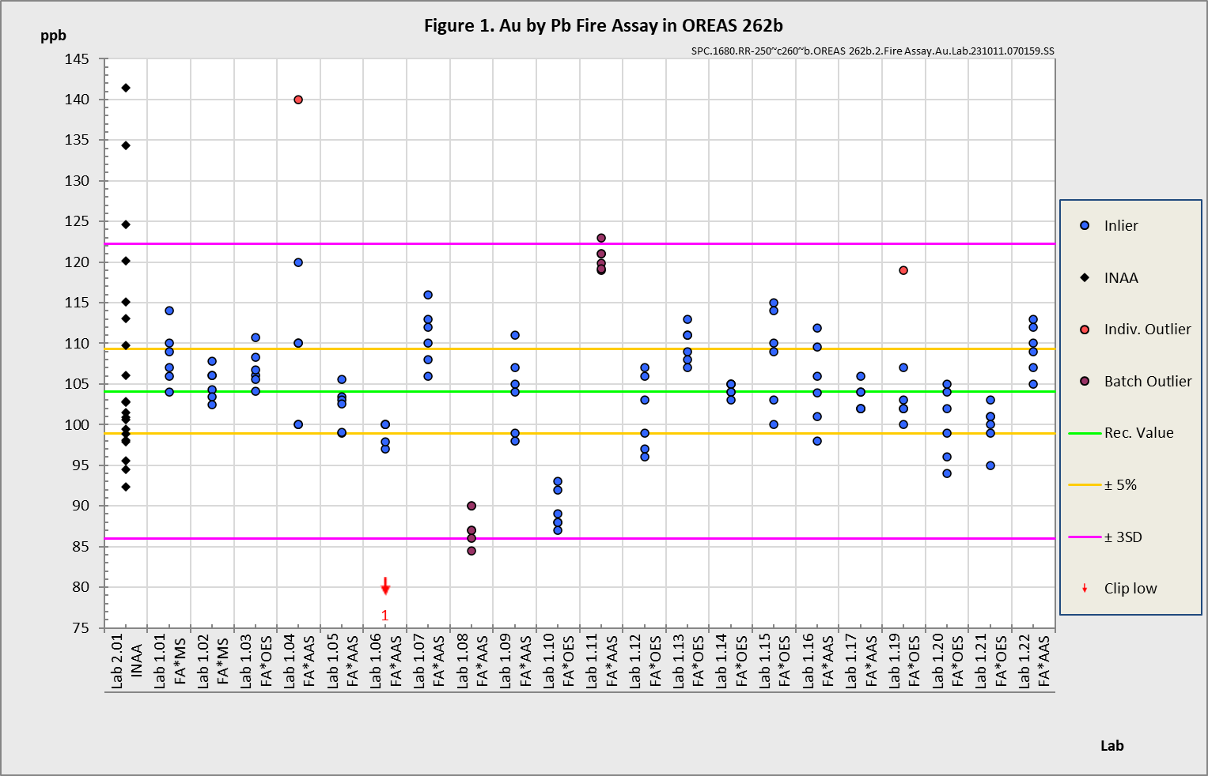
Figure 1. Au by Fire Assay in OREAS 262b

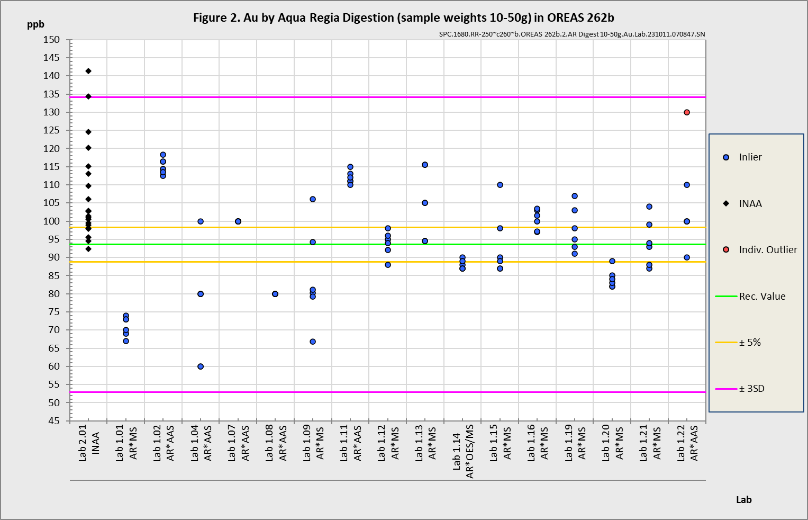
Figure 2. Au by Aqua Regia digestion in OREAS 262b

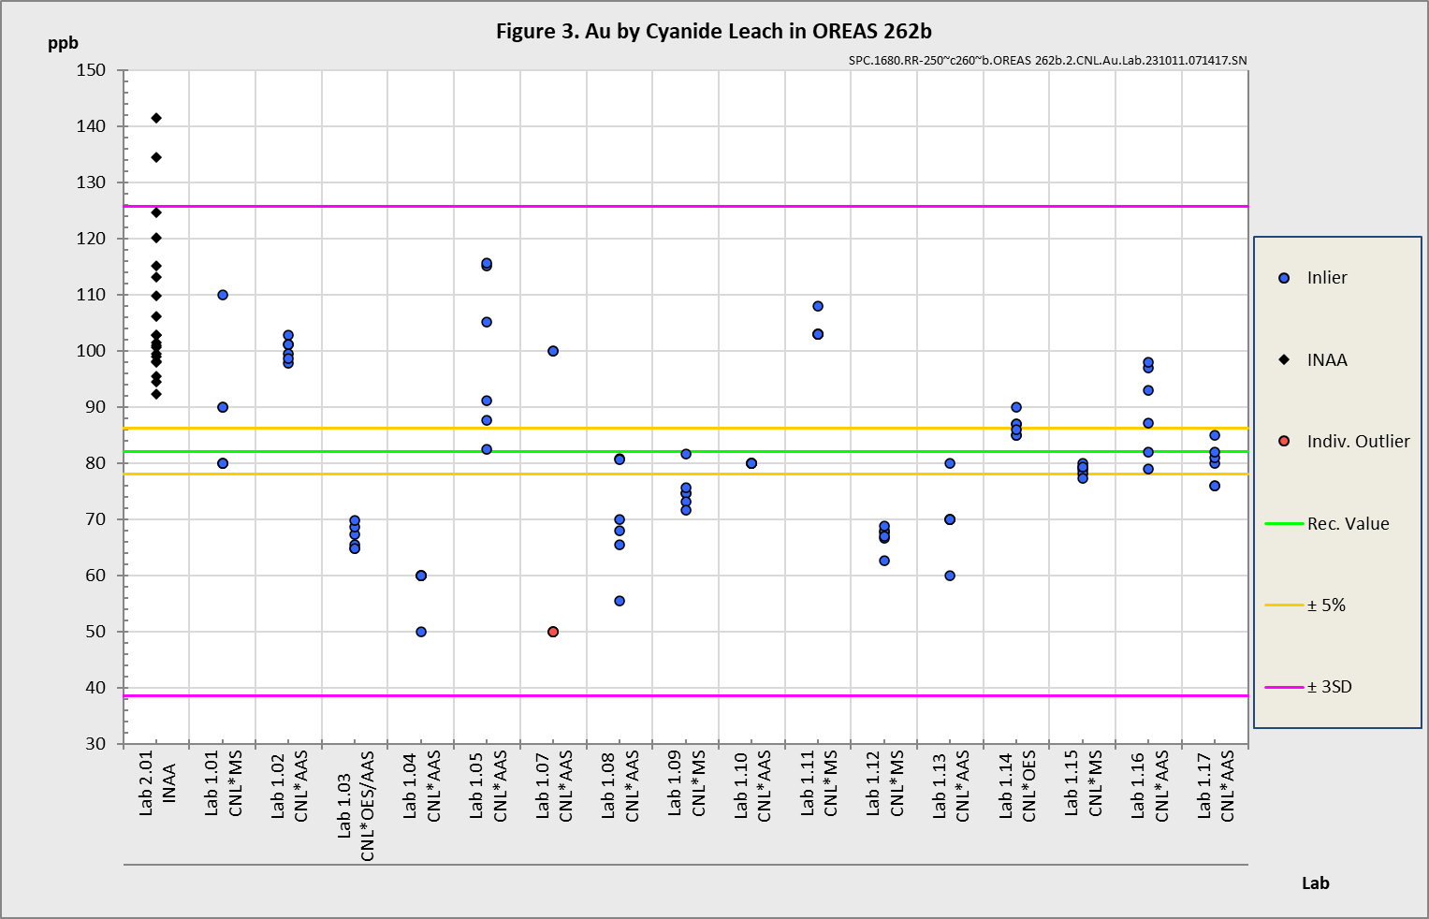
Figure 3. Au by Cyanide Leach in OREAS 262b

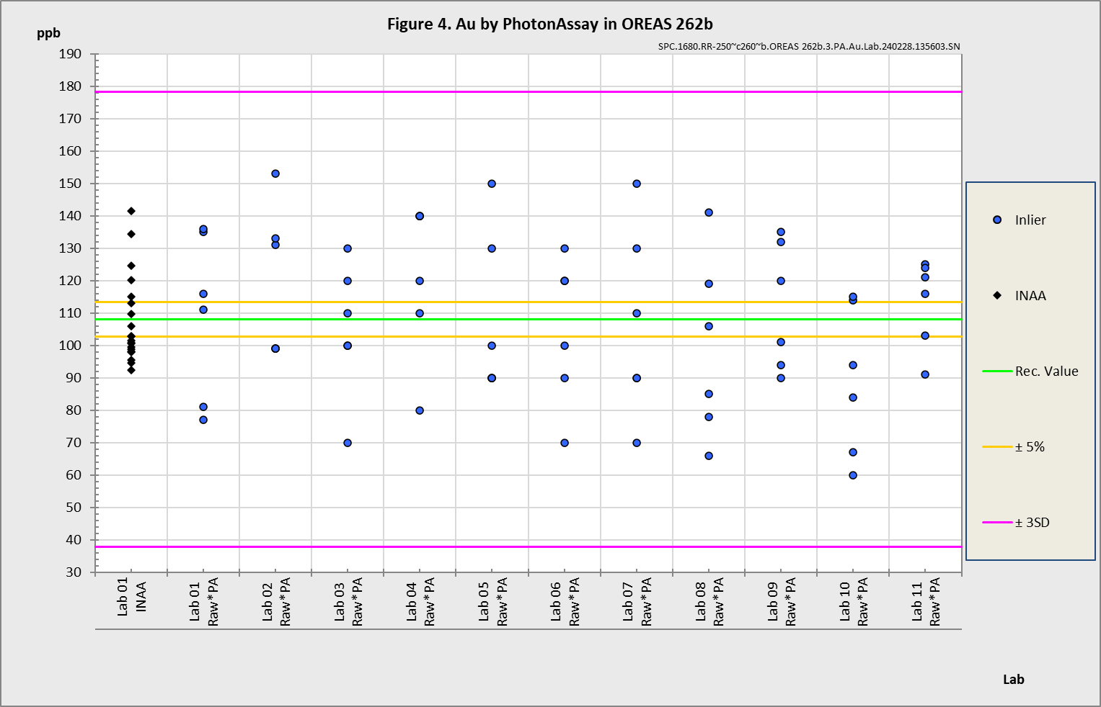
Figure 4. Au by PhotonAssay in OREAS 262b

METROLOGICAL TRACEABILITY

The interlaboratory results that underpin the certified values are metrologically traceable to the international measurement scale (SI) of mass (either as a % mass fraction or as milligrams per kilogram (mg/kg)). In line with popular use, all data within tables in this certificate are expressed as the mass fraction in either weight percent (wt.%) or parts per million (ppm).

The analytical samples sent to participating laboratories were selected in a manner to be representative of the entire prepared batch of CRM. This ‘representivity’ was maintained in each submitted laboratory sample batch and ensures the user that the data is traceable from sample selection through to the analytical results. The systematic sampling method was chosen due to the low risk of overlooking repetitive effects or trends in the batch due to the way the CRM was processed. In line with ISO 17025 [10], each analytical data set received from the participating laboratories has been validated by its assayer through the inclusion of internal reference materials and QC checks during and post analysis.

The participating laboratories were chosen on the basis of their competence (from past performance in interlaboratory programs undertaken by ORE Pty Ltd) for a particular analytical method, analyte or analyte suite and sample matrix. These laboratories are accredited to ISO 17025 for Au by fire assay (Table 1). The other operationally defined measurands characterised in this certificate (Table 2) are derived from data procured mostly from ISO 17025 accredited laboratories. The certified values presented in this report are calculated from the means of accepted data following robust technical and statistical analysis as detailed in this report.

Guide ISO/TR 16476:2016, section 5.3.1 describes metrological traceability in reference materials as it pertains to the transformation of the measurand. In this section it states, “Although the determination of the property value itself can be made traceable to appropriate units through, for example, calibration of the measurement equipment used, steps like the transformation of the sample from one physical (chemical) state to another cannot. Such transformations may only be compared with a reference (when available), or among themselves. For some transformations, reference methods have been defined and may be used in certification projects to evaluate the uncertainty associated with such a transformation. In other cases, only a comparison among different laboratories using the same procedure is possible. In this case, it is impossible to demonstrate absence of method bias; therefore, the result is an operationally defined measurand (ISO Guide 35:2017, 9.2.4c).” Certification takes place on the basis of agreement among operationally defined, independent measurement results.

COMMUTABILITY

The measurements of the results that underlie the certified values contained in this report were undertaken by methods involving pre-treatment (fusion/digestion) of the sample. This served to reduce the sample to a simple and well understood form permitting calibration using simple solutions of the CRM. Due to these methods being well understood and highly effective, commutability is not an issue for this CRM. All OREAS CRMs are sourced from natural ore minerals meaning they will display similar behaviour as routine ‘field’ samples in the relevant measurement process. Care should be taken to ensure ‘matrix matching’ as close as practically achievable. The matrix and mineralisation style of the CRM is described in the ‘Source Material’ section and users should select appropriate CRMs matching these attributes to the field samples being analysed.

INTENDED USE

OREAS 262b is intended to cover all activities needed to produce a measurement result. This includes extraction, possible separation steps and the actual measurement process (the signal producing step). OREAS 262b may be used to calibrate the entire procedure by producing a pure substance CRM transformed into a calibration solution.

OREAS 262b is intended for the following uses:

- For the monitoring of laboratory performance in the analysis of analytes reported in Tables 1 and 2 in geological samples;
- For the verification of analytical methods for analytes reported in Tables 1 and 2;
- For the calibration of instruments used in the determination of the concentration of analytes reported in Tables 1 and 2. When a value provided in this certificate is used to calibrate a measurement process, the uncertainty associated with that value should be appropriately propagated into the user’s uncertainty calculation. Users can determine an approximation of the standard uncertainty by calculating one fourth of the width of the Expanded Uncertainty interval given in this certificate (Expanded Uncertainty intervals are provided in Tables 1 and 2).

MINIMUM SAMPLE SIZE

To relate analytical determinations to the values in this certificate, the minimum mass of sample used should match the typical mass that the laboratories used in the interlaboratory (round robin) certification program. This means that different minimum sample masses should be used depending on the operationally defined methodology as follows:

- Au by fire assay: ≥15g;
- Au by aqua regia digestion: ≥10g;
- Au by cyanide leach: ≥5g;
- Au by PhotonAssay: recommended gross mass* 470-500 g;
- 4-acid digestion with ICP-OES and/or MS finish: ≥0.25g;
- Aqua regia digestion with ICP-OES and/or MS finish: ≥0.5g.

*Gross mass refers to the mass of the entire jar assembly, including jar base, jar lid and contents. These value ranges were developed using a ~40g empty jar mass but should be achievable for any jar-lid combination.

PERIOD OF VALIDITY & STORAGE INSTRUCTIONS

The certification of OREAS 262b remains valid, within the specified measurement uncertainties, until July 2038, provided the CRM is handled and stored in accordance with the instructions given below. This certification is nullified if the CRM is any way changed or contaminated.

Store in a clean and cool dry place away from direct sunlight.

Long-term stability will be monitored at appropriate intervals and purchasers notified if any changes are observed. The period of validity may well be indefinite and will be reassessed prior to expiry with the aim of extending the validity if possible.

Single-use sachets
Following analysis, it is the manufacturer’s expectation that any remaining material is discarded unless the sachet is promptly resealed. It is the user’s responsibility to prevent contamination and minimise exposure to the atmosphere.

Repeat-use packaging (e.g., 500g unit)
After taking a subsample, users should replace the lid of the jar promptly and securely to prevent accidental spills and airborne contamination. OREAS 262b contains a non-hygroscopic* matrix with an indicative value for moisture provided to enable users to check for changes to stored material by determining moisture in the user’s laboratory and comparing the result to the value in Table 4 in this certificate.

The stability of the CRM in regard to oxidation from the breakdown of sulphide minerals to sulphates is negligible given its low sulphur concentration (0.02 wt.% S).

*A non-hygroscopic matrix means exposure to atmospheres significantly different, in terms of temperature and humidity, from the climate during manufacturing should have negligible impact on the precision of results. Hygroscopic moisture is the amount of adsorped moisture (weakly held H₂O- molecules on the surface of exposed material) following exposure to the local atmosphere. Usually, equilibration of material to the local atmosphere will only occur if the material is spread into a thin (~2mm thick) layer and left exposed for a period of 2 hours.

INSTRUCTIONS FOR HANDLING & CORRECT USE

Pre-homogenisation of the CRM prior to subsampling and analysis is not necessary as there is no particle segregation under transport [13].

Fine powders pose a risk to eyes and lungs and therefore standard precautions including the use of safety glasses and dust masks are advised.

QC monitoring using multiples of the Standard Deviation (SD)
In the application of SD’s in monitoring performance it is important to note that not all laboratories function at the same level of proficiency and that different methods in use at a particular laboratory have differing levels of precision. Each laboratory has its own inherent SD (for a specific concentration level and analyte-method pair) based on the analytical process and this SD is not directly related to the round robin program.

The majority of data generated in the round robin program was produced by a selection of world class laboratories. The SD’s thus generated are more constrained than those that would be produced across a randomly selected group of laboratories. To produce more generally achievable SD’s the ‘pooled’ SD’s provided in this report include interlaboratory bias. This ‘one size fits all’ approach may require revision at the discretion of the QC manager concerned following careful scrutiny of QC control charts.

The performance gates shown in Table 7 are intended only to be used as a preliminary guide as to what a laboratory may be able to achieve. Over a period of time monitoring your own laboratory’s data for this CRM, SD's should be calculated directly from your own laboratory's process. This will enable you to establish more specific performance gates that are fit for purpose for your application as well as the ability to monitor bias. If your long-term trend analysis shows an average value that is within the 95% expanded uncertainty then generally there is no cause for concern in regard to bias.

For use with the aqua regia digestion method
It is important to note that in the analytical industry there is no standardisation of the aqua regia digestion process. This method is a partial empirical digest and differences in recoveries for various analytes are commonplace. These are caused by variations in the digest conditions and can include the ratio of nitric to hydrochloric acids, acid strength, temperatures, leach times and secondary digestions. Recoveries for sulphide-hosted base metal sulphides approach total values, however, other analytes, in particular the lithophile elements, show greater sensitivity to method parameters. This can result in lack of consensus in an inter-laboratory certification program for these elements.

The approach applied here is to report certified values in those instances where reasonable agreement exists amongst a majority of participating laboratories. The results of specific laboratories may differ significantly from the certified values, but will, nonetheless, be valid and reproducible in the context of the specifics of the aqua regia method in use. Users of this reference material should, therefore, be mindful of this limitation when applying the certified values in a quality control program.

LEGAL NOTICE

Ore Research & Exploration Pty Ltd has prepared and statistically evaluated the property values of this reference material to the best of its ability. The Purchaser by receipt hereof releases and indemnifies Ore Research & Exploration Pty Ltd from and against all liability and costs arising from the use of this material and information.

© Copyright Ore Research & Exploration Pty Ltd.
Unauthorised copying, reproduction, storage or dissemination is prohibited.

DOCUMENT HISTORY

Revision No. | Date | Changes applied
6 | 12th November, 2025 | Updated the recommended gross mass for use in PhotonAssay analysis.
5 | 17th July, 2025 | Updated the recommended gross mass for use in PhotonAssay analysis.
4 | 11th June, 2025 | Updated the recommended gross mass for use in PhotonAssay analysis.
3 | 06th January, 2025 | Added PhotonAssay method and sample mass to certification.
2 | 18th March, 2024 | Added Au by PhotonAssay certification.
1 | 15th December, 2023 | Added SQ-XRD mineralogical data to Table 5.
0 | 16th October, 2023 | First publication.

CERTIFYING OFFICER

 12th November, 2025
Craig Hamlyn (B.Sc. Hons - Geology), Technical Manager - ORE P/L

QMS CERTIFICATION

ORE Pty Ltd is accredited for compliance with ISO 17034:2016.


ORE Pty Ltd is ISO 9001:2015 certified by Lloyd’s Register Quality Assurance Ltd for its quality management system including development, manufacturing, certification and supply of CRMs.


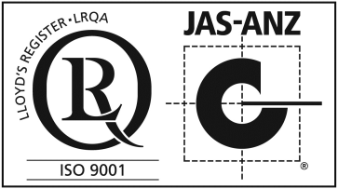

REFERENCES

[1] Govett, G.J.S. (1983). Handbook of Exploration Geochemistry, Volume 2: Statistics and Data Analysis in Geochemical Prospecting (Variations of accuracy and precision).
[2] Ingamells, C. O. and Switzer, P. (1973). A Proposed Sampling Constant for Use in Geochemical Analysis, Talanta 20, 547-568.
[3] ISO Guide 30:2015. Terms and definitions used in connection with reference materials.
[4] ISO Guide 31:2015. Reference materials – Contents of certificates and labels.
[5] ISO Guide 35:2017. Certification of reference materials - General and statistical principals.
[6] ISO Guide 98-3:2008. Guide to the expression of uncertainty in measurement (GUM:1995).
[7] ISO 16269:2014. Statistical interpretation of data – Part 6: Determination of statistical tolerance intervals.
[8] ISO/TR 16476:2016, Reference Materials – Establishing and expressing metrological traceability of quantity values assigned to reference materials.
[9] ISO 17025:2017, General requirements for the competence of testing and calibration laboratories.
[10] ISO 17034:2016. General requirements for the competence of reference material producers.
[11] Munsell Rock Color Book (2014). Rock-Color Chart Committee, Geological Society of America (GSA), Minnesota (USA).
[12] OREAS-BUP-70-09-11: Statistical Analysis - OREAS Evaluation Method.
[13] OREAS-TN-04-1498: Stability under transport; an experimental study of OREAS CRMs.
[14] OREAS-TN-05-1674: Long-term storage stability; an experimental study of OREAS CRMs.
[15] Thompson, A.; Taylor, B.N.; Guide for the Use of the International System of Units (SI); NIST Special Publication 811; U.S. Government Printing Office: Washington, DC (2008); available at: https://physics.nist.gov/cuu/pdf/sp811.pdf (accessed Nov 2021).
[16] Van der Veen AMH and Pauwels, J. (2001). Uncertainty calculations in the certification of reference materials, Accred Qual Assur 6: 290-294.

